TaraNaSaPinas

Project Documentation

Submitted to the Faculty of the

School of Computing and Information Technologies of

Asia Pacific College

In Partial Fulfillment of the Requirements for the course

Software Development

By

Reham Snow A. Camama

Anna Lynn C. Alcaraz

Ma. Fevy C. Espinas

Table of Contents

Abstract 3

List of Figures 4

List of Tables, List of Notations 5

1. Introduction 6

1.1 Project Context 6

1.2 Purpose and Description 6

1.3 Objectives 6

1.4 Scope and Limitations 7

2. Related Literature 7

2.1 Contribution of Tourism to the Philippines’ Economy 7

2.2 Online Travel Agencies Spur Philippine Tourism Growth 7

2.3 Online Travel Agencies 8

3. Technical Background 9

3.1 Integration Development Environment (IDE) 9

3.2 Programming Languages 9

4. Design and Methodology 11

4.1 Requirements Analysis 11

4.2 Requirements Documentation 14

4.3 Gap Analysis/Needs Assessment 15

4.4 Design of Software, Systems, Product, and/or Processes 16

4.5 Development and Testing 19

4.6 Description of Prototype 24

4.7 Implementation Plan (Infrastructure/Deployment) 30

5. Results and Discussions 31

6. Conclusions and Recommendations 31

7. Appendices 32

7.1 Curriculum Vitae 32

References 39

# Abstract

TaraNaSaPinas is a mobile and web application that aims to provide travel agencies and travelers with an online portal where travel agencies and travelers can connect. A mobile application was created as the front-end of TaraNaSaPinas, while a web application was created as the back-end, to be accessible only to the travel agencies. Using the web application, travel agencies can post travel deals and receive travel bookings made by the travelers, while travelers can search for and book travel deals using the mobile application. Bringing together these travel agencies doesn’t only make it convenient for travelers to have access to a lot more travel deals offered in the Philippines, but also give these agencies an opportunity to be discovered and showcase what they have to offer.

# List of Figures

Figure 1. Traveloka Website 8

Figure 2. Expedia Website 8

Figure 3. Use Case Diagram 16

Figure 4. Data Flow Diagram - Context Diagram 18

Figure 5. Data Flow Diagram - Level 0 18

Figure 6. Entity Relationship Diagram 19

Figure 7. Login Page 25

Figure 8. Registration Page 25

Figure 9. Deals Page 25

Figure 10. Deal Information Page 25

Figure 11. Bookings Page 26

Figure 12. Customer Information Page 26

Figure 13. Booking Review Page 26

Figure 14. Booking Details Page 26

Figure 15. Web Application - Sign In Page 28

Figure 16. Web Application - Sign Up Page 28

Figure 17. Web Application - Company Profile Page 29

Figure 18. Web Application - Deals Page 29

Figure 19. Web Application - Bookings Page 30

Figure 20. Web Application - Feedbacks Page 30

# List of Tables, List of Notations

Table 1. Events Table 17

## Introduction

### Project Context

The Philippines is home to many of the most beautiful islands in the world. Because of this, tourism in the country is considered as one of the main contributors to the country’s economy. In 2016, according to the Philippine Statistics Authority, the contribution of tourism to the economy was estimated at 8.6%, as measured by the share of tourism direct gross value added (TDGVA) to the total gross domestic product (GDP).

In recent years, tourism in the country has seen an increase in numbers. Inbound tourism expenditure saw an increase of 2.3 percent in 2016, while domestic tourism expenditure saw an increase of 19.1 percent. Also, last May 2017, according to the Department of Tourism states that visitors in the country has already surpassed the 500,000-mark target. This growth in tourism can be greatly attributed to the effective marketing efforts being done by the Department of Tourism, showcasing the beauty of the country to the world.

TaraNaSaPinas aims to help the Department of Tourism bring the Philippines closer to its potential visitors, both local and foreign. Through TaraNaSaPinas, local travel agencies will be matched and connected to the travelers, and safe and affordable travel deals within the Philippines, prepared by certified travel agencies in the country, will be made available to every potential traveler.

Ensuring the safety of the travelers is always the top priority. The web application would be handed over to the Department of Tourism. Through TaraNaSaPinas, the Department of Tourism can check that travel agencies are properly registered and documented before approving their registration to the application. Through TaraNaSaPinas, the Department of Tourism can also monitor the travel agencies registered in the application.

### Purpose and Description

TaraNaSaPinas is available as both a web application and a mobile application. The web application is accessible only to the Department of Tourism as the application’s system administrator, and to the registered travel agencies. On the other hand, TaraNaSaPinas is a one-stop mobile application for travelers. Travelers can view, search, and book travel deals using the mobile application. The purpose of the application is to connect travelers with travel agencies in the Philippines.

### Objectives

TaraNaSaPinas aims to:

* support local travel agencies around the Philippines;
* ensure safety of travelers in terms of credibility of travel agencies; and
* be an avenue for the market with regards to a hassle-free booking of travel deals.

### Scope and Limitations

* Travelers can only access the application through the mobile application, which serves as the front-end of TaraNaSaPinas. Only the system administrator and the travel agencies can access the web application, which serves as the back-end of TaraNaSaPinas.
* Accessing the mobile application requires internet connection and may be affected by the quality of the internet connection.
* As for the initial release of TaraNaSaPinas, and as part of promoting local tourism in the Philippines, travel and tour deals that will be allowed for posting in the application are limited to deals with destinations within the country.
* The availability of the travel and tour deals is dependent on the posts and offers made by the travel agencies.
* The inclusions and price of the travel and tour deals are also dependent the posts and offers made by the travel agencies.

## Related Literature

### Contribution of Tourism to the Philippines’ Economy

According to the Philippine Statistics Authority, the contribution of tourism to the economy was estimated at 8.6 percent in 2016, as measured by the share of tourism direct gross value added (TDGVA) to total gross domestic product (GDP) (Perez, 2017). Inbound tourism expenditure saw an increase of 2.3 percent in 2016, amounting to PhP 313.6 billion in 2016 from PhP 306.6 billion in 2015, while domestic tourism expenditure saw an increase of 19.1 percent, amounting to PhP 2,108.2 billion in 2016 from PhP 1,770.7 billion in 2015.

### Online Travel Agencies Spur Philippine Tourism Growth

The growth on tourism in the Philippines is driven by technology (INQUIRER.net BrandRoom, 2017). Because of online travel agencies (e.g. Traveloka), travel has now been made more accessible for everyone, changing the ways travelers book their trips. Nowadays, travelers turn to online travel agencies (OTA) to book their trips for greater convenience, easy price comparisons, quick promo notifications, diverse payment options, minimal risks, and better customer service. The abundance of information online makes it easier for first-time visitors to learn about the place, and has also prompted flight carriers and lodging providers to offer competitive prices (Manila Bulletin, 2017). Online travel agencies offer unparalleled convenience, enabling travelers to book easy, fast, and secure while on-the-go.

### Online Travel Agencies

Online travel agencies, with their websites and mobile applications, have made booking trips possible for travelers anytime, anywhere. Traveloka and Expedia, both online travel agencies, are one-stop travel booking apps, offering travel deals from partner airlines and hotels (Traveloka, 2018) (Expedia.com.ph, 2018). Real guest reviews from users who have previously booked are also available. Customer service is also available 24/7 to assist travelers with any of their travel concerns, anytime, anywhere. Traveloka and Expedia promise convenience with their multi-channel payment options, all accessible through website, or through mobile application. Figure 1 shows the website of Traveloka, while Figure 2 shows the website of Expedia.

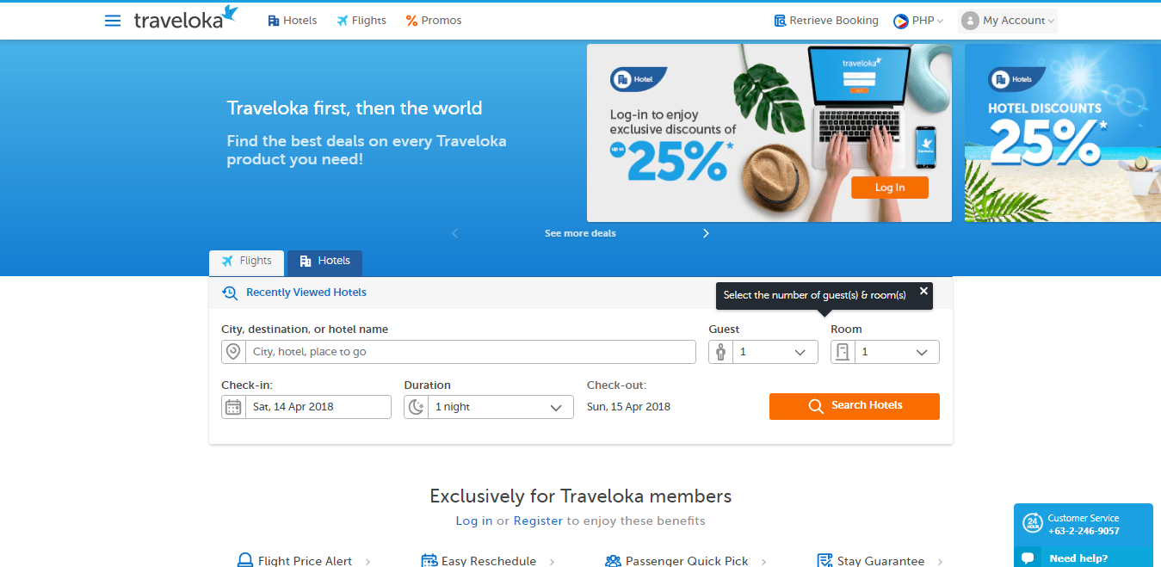

Figure 1. Traveloka Website

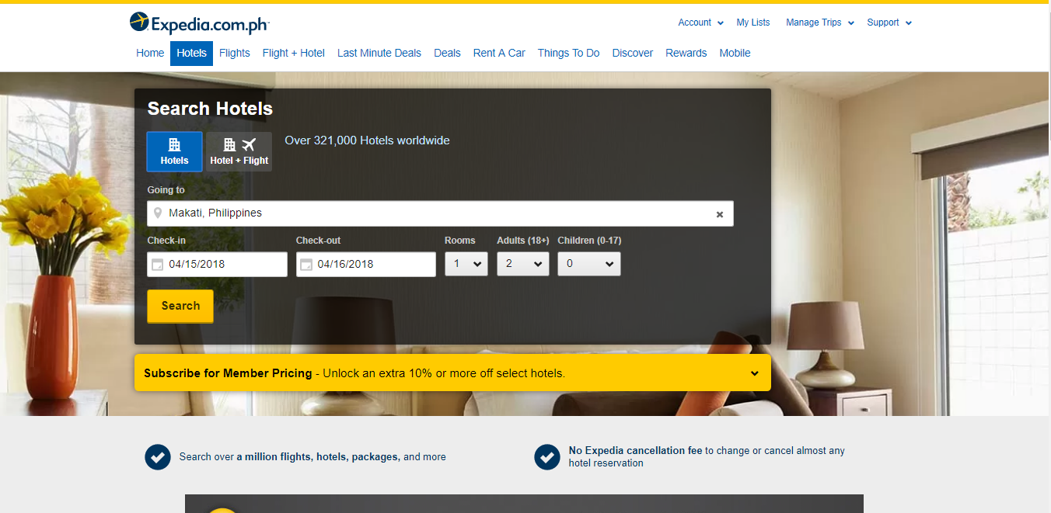

Figure 2. Expedia Website

## Technical Background

The developers used (1) Android Studio and (2) Visual Studio Code as the official Integration Development Environment (IDE) for the mobile application and web application, respectively. The developers used the programming languages, (3) Java and (4) PHP, for the mobile application and web application, respectively. The web developers used (5) Laravel as the PHP web application framework. The developers also used (5) XAMPP as the web server and (6) MySQL as the open source Relational Database Management System for deploying, testing and saving the data for both mobile and web application.

### Integration Development Environment (IDE)

An Integration Development Environment is a software that provides basic tools such as editor, compiler or interpreter and debugger. It also allows the programmers to test and run their code. It improves programmers’ productivity as the tools needed for development can be accessed in just a single software.

#### 3.1.1 Android Studio

Android Studio is used for developing Android applications. It was developed by Google; therefore, it can integrate Google App Engines, such as Application Programming Interface (APIs) and features. Android Studio is the ideal IDE for android app development.

#### 3.1.1 Visual Studio Code

Visual Studio Code is known as a great editor for PHP development. Aside from the known features – syntax highlighting, bracket matching, auto-indentation and snippets – the developer can also add more functionality through the community created VS code extensions (code.visualstudio.com, 2018). It also supports Git. Visual Studio Code is the ideal IDE for developing web application using PHP because it helps the developers to be more productive and perform tasks workflow faster since it has many features including the IntelliSense code completion and code refactoring.

### Programming Languages

#### 3.2.1 Java

Java is a high-level programming language that produces software development, mobile applications and large systems. Java can run in different platforms, such as Windows and Unix. It is based on the syntax of C and C++ programming languages but is an object-oriented programming language which contains classes and methods. Java would be the ideal programming language for developing a mobile application in Android Studio.

#### 3.2.1 PHP

PHP is a scripting language used for creating dynamic and interactive web pages. It is an open-source and cross-platform language. One type of an open-source PHP web framework is Laravel. The developers used Laravel as the framework for developing the web application since it is designed for the developers who needs a simple yet user-friendly toolkit to create full-featured web applications.

#### 3.1.3 XAMPP

XAMPP is a free and open-source platform web server. It consists of Apache HTTP Server, MariaDB Database and interpreters for scripts written in PHP and PERL programming languages. It is ideal to use because it is easy for developers to create a local web server for testing and deploying it to a live server.

#### 3.1.4 Database: MySQL & Firebase

A database is a collection of related records or data. One type of database is relational database. It uses a structure that allows users to identify and access a data that is in relation to another data in the database. It is often organized into tables. Thus, a program that allows users to create, update and manage a relational database is called Relational Database. To access the database, the user should use the SQL language.

MySQL is the most popular open source RDBMS. The advantages of using the MySQL for the users is that it is easy to use, inexpensive, reliable and is the improved accessing and sharing data. The database is very important for it would be a huge part of the project. Since the project is all about business and deals, this is where all the data, such as travel agency and travelers’ information, deals, history records, and many more – will be kept.

Furthermore, Firebase database will be used for the authentication: registration and login part of the mobile application since it is stipulated that it is a powerful tool that connects mobile application to various functionalities easily

## Design and Methodology

### Requirements Analysis

|  |
| --- |
| **OUTPUT** |
| * The following must be present in the mobile application:   + Registration and/or Login Form   + User Account   + Travel and Tour Deals * The Traveler must be able to view/see the following in the mobile application:   + His/her profile   + Travel Agency’s profile   + The most recommended travel and tour deals   + The most recommended travel agencies   + The most cheapest to the most expensive travel and tour deals   + The travel and tour deals offered in a specific location   + The details of travel and tour deals   + The availability of a travel and tour deal given number of PAX, and travel date   + Images of tour destinations   + His/her booking status   + His/her travel docket for confirmed booking   + His/her schedule travels   + Feedback in a travel agency and its travel and tour deals * The Traveler must be notified on any change on his/her booking status and new message requests. * The following must be present in the web application:   + Registration/Login Form   + User Account   + Create Travel and Tour Deals Form * The Travel Agency must be able to see/view the following in the web application:   + Account details   + Prioritization on booking requests   + Overall rating by the Travelers   + Feedbacks that has been given by the Travelers   + Their own travel and tour deals’ rating given by the Travelers   + Feedbacks on their travel and tour deals * The Travel Agency must be notified on booking requests, account’s approval status and new message requests. * The System Administrator must be able to see/view the following in the web application:   + Account details   + Travel agencies’ performance * The System Administrator must be notified with new account approval and account change requests. |

|  |
| --- |
| **INPUT** |
| * Travel Agency and System Administrator must enter an employee email and password to access web application for verification. * Traveler must sign up to the mobile application. Each must provide the following:   + Email   + First Name   + Last Name   + Contact Number   + Password   + Birthdate * Travel Agency and System Administrator that will the accessing the system can sign up with the privilege of one of the managers, through providing the following:   + Name   + Email   + User type (Travel Agency, System Administrator)   + Password * Travel Agency must input the following to create a profile:   + Company Name   + Address   + Contact Number   + Email Address   + Business Permit Number   + Additional Details   + Website URL   + Company logo (picture) * Adding and posting of travel and tour deals can only be created by the Travel Agency. * Travel and Tour Deals made by the Travel Agency will be posted to the mobile application. * Booking travel will be inputted by the Traveler to the mobile application, including the number of days, PAX, travel start date, and travel date to travel end date. * After booking a deal, the Traveler must input his/her booking contact information through providing the following: * First Name * Last Name * Email * Contact Number * Traveler can filter the travel and tour deals by the most recommended travel agency or travel deals. The traveler can also sort the travel and tour deals by cost- selecting from the range of: * 0-1999 PHP * 2000-4999 PHP * 5000-9999 PHP * 10,000 PHP UP |

|  |
| --- |
| **PROCESS** |
| * The system must automatically save and synchronize all data that is entered by the travel agency to the traveler through updating with the use of cellular data or Wi-Fi. * The System must automatically categorize the Travel Agency or System Administrator and their user privileges. * The system must automatically send all the booking requests from the mobile application to the database of the web application. * The system must automatically send all the new message requests from the mobile application to the database of the web application, and vice versa. |
| **PERFORMANCE** |
| * The system must be able to receive booking requests automatically. * The system must generate the overall rating and feedbacks from the Travelers to the Travel Agency. * The system must notify the Travelers on any change in the booking status, new message requests and travel and tour deals suggestions- from the Travel Agency real time, given that they have cellular of Wi-Fi access. * The system must notify the Travel Agency on account’s approval status, booking requests and new message request. * The system must notify the System Administrator on new Travel Agency account approval requests and with the account change requests. * The system must be able to track the Travel Agencies’ performance. |
| **CONTROL** |
| * The Travel Agencies are the only ones authorized to post and add all travel and tour deals of their own company. * The Travel Agencies are the only ones who can approve the booking requests of the traveler. * The System Administrator are the only ones who can approve the new Travel Agency account requests. |

### Requirements Documentation

|  |  |  |  |
| --- | --- | --- | --- |
| **Software Requirements** | | | |
| **Module** | **User** | **Feature** | **Status** |
| Accounts | Traveler,  Travel Agency, System Administrator | Sign Up | Done |
| Sign In | Done |
| Sign Out | Done |
| Reset Password | Done |
| System Administrator | View Travel Agencies | Done |
| View Travel Agency Profile | Done |
| Update Travel Agency Status | Done |
| Profile | Traveler,  Travel Agency | Create Profile | Done |
| Update Profile | Done |
| View Profile | Done |
| Deals | Traveler | Filter Travel Deals by rating of  travel deals or travel agencies | Done |
| Sort Travel Deals by price | Done |
| Search Travel Deals by location | Done |
| View Deal Details | Done |
| Travel Agency | Create Deal | Done |
| View All Deals | Done |
| View Deal Details | Done |
| Update Deal Details | Done |
| Delete Deal | Done |
| Bookings | Traveler | Book Travel Deal | Done |
| View Booking Status | Done |
| Travel Agency | View All Bookings | Done |
| View Booking Details | Done |
| Update Booking Status | Done |
| Rating and Feedback | Traveler | Rate Travel Deal | Done |
| Rate Travel Agency | Done |
| Submit Feedback on Deal | Done |
| Submit Feedback on Travel Agency | Done |
| Travel Agency | View Deal Ratings | Done |
| View Deal Feedbacks | Done |
| View Ratings | Done |
| View Feedbacks | Done |
| Inquiries | Traveler | Send Inquiries | Done |
| Travel Agency | Send Reply to Inquiry | Done |
| Alerts and Notifications | Traveler | Travel Deal Suggestions |  |
| Booking Status Updates |  |
| Reply to Inquiry |  |
| Travel Agency | Account Status Updates |  |
| Booking Requests |  |
| Inquiries |  |
| System Administrator | New Travel Agency |  |

### Gap Analysis/Needs Assessment

In the survey conducted by the product owner, Marielet A. Guillermo, travelers were asked where they usually search for travel packages. The survey can be accessed through the link: <https://goo.gl/forms/kt7RjL3BEy4RfZJG3>. The following table shows the gap between TaraNaSaPinas and various existing travel and tour deals setups and systems.

|  |  |  |  |  |  |
| --- | --- | --- | --- | --- | --- |
| **Features / Functionalities** | **Existing Setup/Systems** | | | | **New System** |
| **Flyers** | **Billboard Ads** | **Social Media** | **Recommendation from a friend** | **TaraNaSaPinas** |
| Travel and/or Tour Deals Information | ✔ | ✔ | ✔ | ✔ | ✔ |
| Contact Number | ✔ | ✔ | ✔ | ✔ | ✔ |
| Website URL / Facebook Page | ✔ | ✔ | ✔ | ✔ | ✔ |
| Group Chat |  |  | ✔ |  |  |
| Private Chat |  |  | ✔ |  | ✔ |
| Search Function |  |  | ✔ |  | ✔ |
| Sort Function |  |  |  |  | ✔ |
| Filter Function |  |  |  |  | ✔ |
| Feedback/Rating |  |  | ✔ |  | ✔ |
| Travel Agencies’ Credibility  (with records and  legal documents) |  | ✔ |  |  | ✔ |
| Travel Booking History |  |  |  |  | ✔ |
| **ANALYSIS** | | | | | |
| Because TaraNaSaPinas has more features and functionalities than the existing setup/systems, travelers no longer have to check the credibility of the travel agency and the travel deal, and can now be able to search, sort, and filter travel deals with ease. | | | | | |

### Design of Software, Systems, Product, and/or Processes

TaraNaSaPinas is available as both a mobile application and a web application. The mobile and web applications were designed using the Use Case Diagram, Events Table, Data Flow Diagram, Entity Relationship Diagram, and Activity Diagrams.

The Use Case Diagram shows the type of users, Traveler, Travel Agency, and System Administrator, that will be accessing the system, TaraNaSaPinas. The Use Case Diagram also shows the features or functionalities of the system and which user type/s have access to the feature or functionality. Figure 3 shows the Use Case Diagram.

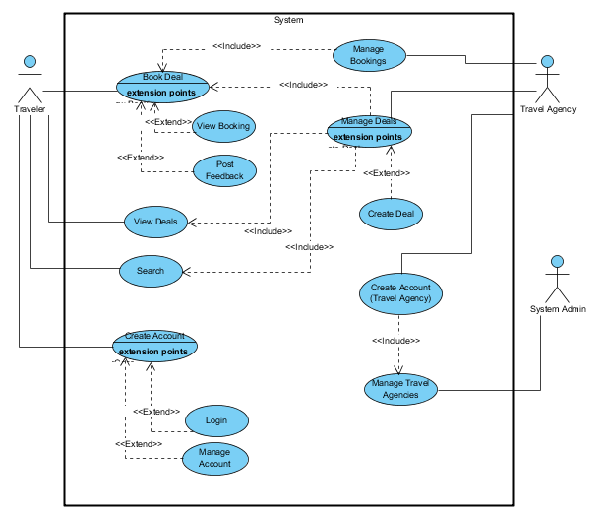

Figure 3. Use Case Diagram

The Events Table gives more details to the features or functionalities shown in the Use Case Diagram. The Events Table shows the trigger, source, response, and destination for each event and use case. Table 1 shows the Events Table.

Table 1. Events Table

|  |  |  |  |  |  |
| --- | --- | --- | --- | --- | --- |
| **EVENT** | **TRIGGER** | **SOURCE** | **USE CASE** | **RESPONSE** | **DESTINATION** |
| Traveler wants to create an account (1) | Registration | Traveler | **Create an Account** | Registration Details | System/ Traveler |
| Traveler wants to search deals (2) | Search Deals | Traveler | **Search** | Deal Details | Traveler |
| Traveler wants view deals (3) | View all deals | Traveler | **View Deals** | Deal Details | Traveler |
| Traveler wants to book deals (4) | Book Deal | Traveler | **Book Deal** | Booking Details | System Database |
| Travel Agency wants to create an account (1) | Registration | Travel Agency | **Create an Account**  **(Travel Agency)** | Registration Details | System/Travel Agency |
| Travel Agency wants to manage deals (2) | Manage Deals | Travel Agency | **Manage Deals** | Deal Details | System Database |
| Travel Agency wants to manage bookings (3) | Manage Bookings | Travel Agency | **Manage Bookings** | Booking Details | System Database |
| System Admin wants to manage travel agencies (1) | Manage Travel Agencies | System Admin | **Manage Travel Agencies** | Travel Agency details | System Admin |

The Data Flow Diagram illustrates how data is inputted, processed, and outputted in the mobile application and web application. In the Context Diagram of the Data Flow Diagram, the three user types, Traveler, Travel Agency, and System Administrator are the external entities (shown as rectangle) that inputs data to the system (shown as rounded rectangle), TaraNaSaPinas. The system processes these data, then outputs the information to the external entities. Figure 4 shows the Context Diagram of the Data Flow Diagram.

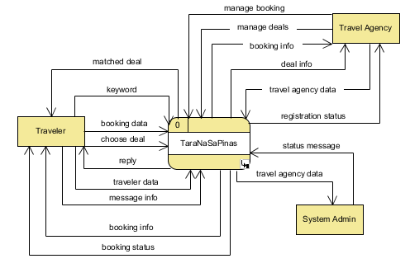

Figure 4. Data Flow Diagram - Context Diagram

In the Level 0 Diagram of the Data Flow Diagram, the three user types are also shown as the external entities (shown as rectangle) that inputs the data. The use cases in the Use Case Diagram and Events Table are depicted as processes (shown as rounded rectangle) that (1) accepts data from the external entities and stores these data to the data stores (shown as an open rectangle) or (2) takes data stored in the data stores and processes the data to be outputted to the entities as information. Figure 5 shows the Level 0 Diagram of the Data Flow Diagram.

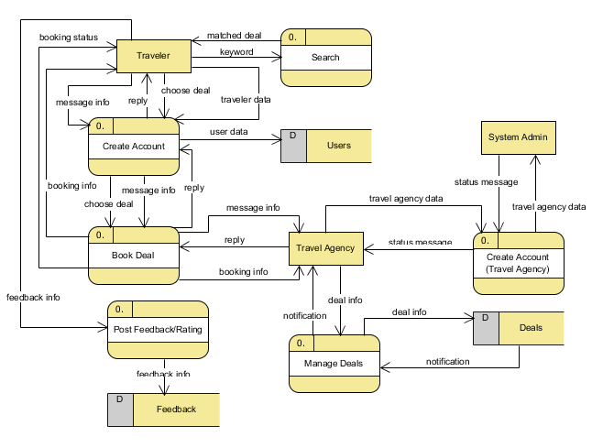

Figure 5. Data Flow Diagram - Level 0

The Entity Relationship Diagram represents the database that will be used for TaraNaSaPinas. The mobile application and the web application will be sharing a common database; thus, it is important that both the mobile application and the web application follow the database design depicted in the Entity Relationship Diagram. The Entity Relationship Diagram shows the different entities, the attributes of each entity, the data type of each attribute, the primary key and foreign key/s of each entity, and the relationship between the entities. Figure 6 shows the Entity Relationship Diagram.

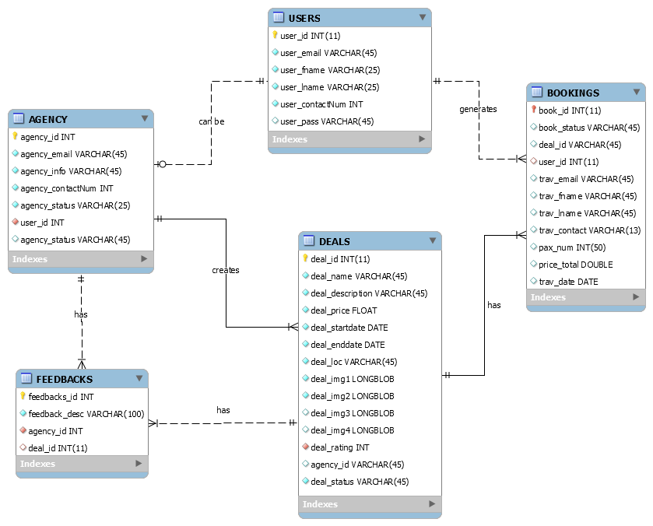

Figure 6. Entity Relationship Diagram

### Development and Testing

The mobile and web application was developed by the Software Development Team of TaraNaSaPinas. Development was done in 5 sprints, which lasted for 2 weeks each. Milestones for every sprint were listed, defined, assigned, and documented in the Product Backlog given by the Project Client. The Development Team met with the client after every sprint to report the status and the progress of the team.

The mobile application was developed using the Android Studio IDE, while the web application was developed using the Visual Studio Code IDE. The web application was created using the PHP web application framework, Laravel. mySQL was the database used for both web application and mobile application.

During the development phase of the project, the Development Team used the Android Emulator to run the mobile application. The Development Team used xampp to run the web application and database via localhost of the computer.

Testing of the mobile application and web application was done by the Software Quality Assurance (SQA) Team of TaraNaSaPinas. The Development Team and the SQA Team met at the end of each sprint to report the status and the progress of the team.

Manual test cases for the user interface and functionalities of the mobile app and web app were created by the SQA Team. Using the manual test cases, the SQA Team performed automated testing using the Katalon Studio. Failed test cases are then documented and reported to the Development Team.

**Test Cases for Use Case: Manage Accounts**

This document provides an overview of test cases for the TaraNaSaPinas project use case, *Manage Accounts*.

**1.1 Scope**

The test cases described in this document cover all techniques by which a user can create and access an account for the TaraNaSaPinas app.

**1.2 Definitions, Acronyms and Abbreviations**

DOB – Date of Birth

**1.3 Overview**

The **Functional Test Cases** document contains the test cases that will be used to evaluate the TaraNaSaPinas app. The user interface and the functionalities of each use case of the TaraNaSaPinas app will be tested with their own set of test cases. The condition being tested and the expected result of each test case will be specified in the document.

**Test Cases**

In each of these test cases, the results are verified by visual inspection.

**1.4 Test Case Group 1: User Interface**

|  |  |  |
| --- | --- | --- |
| **TC ID** | **Condition Being Tested** | **Expected Result** |
| UITC_MeAt1 | Sign Up Page | Displays **Name**, **Email Address**, **Password**, and **Confirm password** text boxes.  Displays Sign Up button.  Displays Sign In page link. |
| UITC_MeAt2 | Sign In Page | Displays **Email Address** and **Password** text boxes.  Displays Sign In button.  Displays Remember Me check box.  Displays Sig Up page link.  Displays Forgot your password? page link to Password Reset Request page |
| UITC_MeAt4 | Password Reset Request Page | Displays **Email** **Address** text box.  Displays Send Password Reset Link button.  Displays Sign In and Sign Up pages link. |
| UITC_MeAt5 | Reset Password Page | Displays **Email Address**, **Password**, and **Confirm password** text boxes.  Displays Reset Password button.  Displays Sign In and Sign Up pages link. |

**1.5 Test Case Group 2: Functionality**

|  |  |  |  |
| --- | --- | --- | --- |
| **TC ID** | **Condition being tested** | **Full Name/ Email / Password / Confirm Password** | **Expected Result** |
| FTC_CeAt 1 | Password text box encodes entry | Empty string / Empty string/ “qwerty” / “qwerty” | Password and Confirm password text boxes should have a string “******” displayed. |
| FTC_CeAt 2 | Blank Full Name, Email, Password, and Confirm password | Empty string / Empty string / Empty string / Empty string | A message will be displayed below the Full Name text box: Please fill out this field. |
| FTC_CeAt 3 | Valid Full Name with blank Email, Password, and Confirm password | “Anna Alcaraz” / Empty string / Empty string / Empty string | A message will be displayed below the Email text box: Please fill out this field. |
| FTC_CeAt 4 | Valid Full Name, with invalid Email, and blank Password and Confirm password | “Anna Alcaraz” / “acalcaraz” / Empty string / Empty string | A message will be displayed below the Email text box: Please enter an email address. |
| FTC_CeAt 5 | Valid Full Name and Email with blank Password and Confirm password | “Anna Alcaraz” / “acalcaraz@student.apc.edu.ph” / Empty string / Empty string | A message will be displayed below the Password text box: Please fill out this field. |
| FTC_CeAt 6 | Valid Full Name, Email, and Password with blank Confirm password | “Anna Alcaraz” / “acalcaraz@student.apc.edu.ph” / “qwerty” / Empty string | A message will be displayed below the Confirm password text box: Please fill out this field. |
| FTC_CeAt 7 | Valid Full Name and Email but Password and Confirm password do not match | “Anna Alcaraz” / “acalcaraz@student.apc.edu.ph” / “qwerty” / “asdfgh” | An error message will be displayed: The password confirmation does not match. |
| FTC_CeAt 8 | Valid Full Name and Email with matching Password and Confirm password | “Anna Alcaraz” / “acalcaraz@student.apc.edu.ph” / “qwerty” / “qwerty” | Redirected to Home page. |
| FTC_CeAt 9 | Valid Full Name, matching Password and Confirm password with registered Email | “Snow Camama” / “acalcaraz@student.apc.edu.ph” / “qwerty” / “qwerty” | An error message will be displayed: The email has already been taken. |

**Test Cases for Use Case: Booking**

This document provides an overview of test cases for the TaraNaSaPinas project use case, *Booking*.

**1.6 Scope**

The test cases described in this document cover all techniques by which a user manager his/her booking

**1.7 Overview**

The **Functional Test Cases** document contains the test cases that will be used to evaluate the TaraNaSaPinas app. The user interface and the functionalities of each use case of the TaraNaSaPinas app will be tested with their own set of test cases. The condition being tested and the expected result of each test case will be specified in the document.

**1.8 Test Case Group 1: User Interface**

|  |  |  |
| --- | --- | --- |
| **TC ID** | **Condition Being Tested** | **Expected Result** |
| UITC_BK1 | Deals Page | Displays list of deals available from all travel agencies |
| UITC_BK2 | Deals Information Page | Displays Location, Date, Travel Agency text boxes  Displays deals’ images  Displays inclusions and exclusions textboxes  Display Book Deal button  Display Message button |
| UITC_BK3 | Booking Page | Display date picker  Display number picker  Display start date and end date textboxes  Display total textboxes  Display Book Deal button |
| UITC_BK4 | Booking Contact Page | Display First Name edit text  Display Last Name edit text  Display Contact Number edit text  Display Email edit text  Display Continue button |
| UITC_BK5 | Booking Review Page | Display Location, start date, end date, pax textbox  Display Continue button |

**1.9 Test Case Group 2: Functionality**

|  |  |  |  |
| --- | --- | --- | --- |
| **TC ID** | **Condition being tested** | RecyclerView | **Expected Result** |
| FTC_CeAt 1 | User enters deal page |  | All deals must be visible in the home page |

|  |  |  |  |
| --- | --- | --- | --- |
| **TC ID** | **Condition being tested** | **Location/Date/Agency/**  **Inclusion/Exclusion/Deal button/Message button** | **Expected Result** |
| FTC_CeAt 1 | User enters a specified deal |  | Location of deal must be displayed automatically,  Start date and end date must be displayed,  Agency must be displayed,  Inclusion and Exclusion must be displayed. |
| FTC_CeAt 2 | Deal Button clicked | Triggered (Deal Button) | Page must redirect to booking page |
| FTC_CeAt 3 | Message Button clicked | Triggered (Message Button) | Page must redirect to message page |

|  |  |  |  |
| --- | --- | --- | --- |
| **TC ID** | **Condition being tested** | **Date Picker/Number Picker/Start date/end date/ total/ Book Deal button** | **Expected Result** |
| FTC_CeAt 1 | Date picker is clicked | Triggered/null/null/null/null | Page must show the date picker dialog. |
| FTC_CeAt 2 | Number picker is clicked | Triggered/2/null/null/null | PAX text box must show “2” |
| FTC_CeAt 3 | Start date textbox | Triggered/2/02-01-2000/null/null | Start date textbox must show “02-01-2000” |
| FTC_CeAt 4 | End date textbox | Triggered/2/02-01-2000/02-20-2000/null/null | End date must show “02-20-2000” |
| FTC_CeAt 5 | Total textbox | Triggered/2/02-01-2000/02-20-2000/8000/null | Total must show “8000” |
| FTC_CeAt 6 | Deal Button | Triggered/2/02-01-2000/02-20-2000/8000/triggered | Page must redirect to contact info page. |

### Description of Prototype

The mobile application is where the traveler can view, search, and book deals. It is an important factor for the mobile application to leave an impact to the market. The team decided to have the color palette of the application to be blue and yellow, also in agreement with the product owner. The Login Page displays the official logo of the application. The user/traveler must login or register first prior to accessing the mobile application.

The mobile application of the TaraNaSaPinas consists of the

* Sign In Page,
* Sign Up Page,
* Travel Agency Page,
* Deals Page,
  + View All Deals,
  + Set Filter by Deal, Cost and Travel Agency, View Deal Details,
* Bookings Page,
  + Book Deal,
  + Customer Information Page,
  + Booking Details,
  + Booking Review,
* Feedbacks Page, and
* Inquiries Page.

|  |  |
| --- | --- |
| Figure 7. Login Page | Figure 8. Registration Page |
| Figure 9. Deals Page | Figure 10. Deal Information Page |
| Figure 11. Bookings Page | Figure 12. Customer Information Page |
| Figure 13. Booking Review Page | Figure 14. Booking Details Page |

The web application of TaraNaSaPinas consists of the

* Sign In Page,
* Sign Up Page,
* Reset Password Request Page,
* Reset Password Page,
* Home Page,
* Travel Agencies Page,
* Company Profile Page (Create, View, and Update),
* Deals Page (View All, Add, Update, and View One),
* Bookings Page (View All, Add, Update, and View One),
* Feedbacks Page (View All, and View One),
* Inquiries Page (View All, View One, and Send Reply)

The Sign Up Page, Sign In Page, Reset Password Page, and Reset Password Request Page of the web application allows the users (system administrator and travel agencies) to create an account and to access them. The Home Page of the web application allows users to access the different pages upon signing in.

Travel agencies create their company profile upon creating an account. The company profile includes the name of the travel agency, business permit number, address, contact number, email address, website URL, company logo, and an About Us. After creating the company profile, travel agencies can also view and update their profile. When viewing their company profile, travel agencies can also view their average travelers’ rating. Travel agencies can also view all the ratings and feedbacks posted by their clients.

The system administrator can access the Travel Agencies Page. In the Travel Agencies Page, the system administrator can view a list of all travel agencies registered in the web application. The system administrator can view details of the travel agency, such as travel agency name, business permit number, address, contact number, email address, and status. Travel agencies are given the Pending status upon registration. The system administrator can then change the status of the travel agency to Approved upon confirmation of the details posted by the travel agency. The system administrator can also view the average of the travelers’ rating of the travel agencies, and can therefore, monitor their performance.

Using the web application, travel agencies can post travel deals. When posting travel deals, travel agencies must include the travel destination, selling period, travel period, price, tour highlights, deal inclusions and exclusions, travel itinerary, and deal images. Travel agencies can also view a list of all their posted deals, view and update deal details, and delete deals. Travel agencies can also view the average travelers’ rating of each deal, or view each rating and feedback posted by travelers.

Travel agencies can receive travelers’ bookings using the web application. The travel agencies receive details such as deal name, travel date, number of persons traveling, and customer information. Travel agencies can view a list of all bookings posted and view the details of every booking. Through the booking page, travel agencies, can update their clients of the status of their booking, and can also send their travel docket.

Travel agencies can receive inquiries sent by travelers, and can also reply to their inquiries.

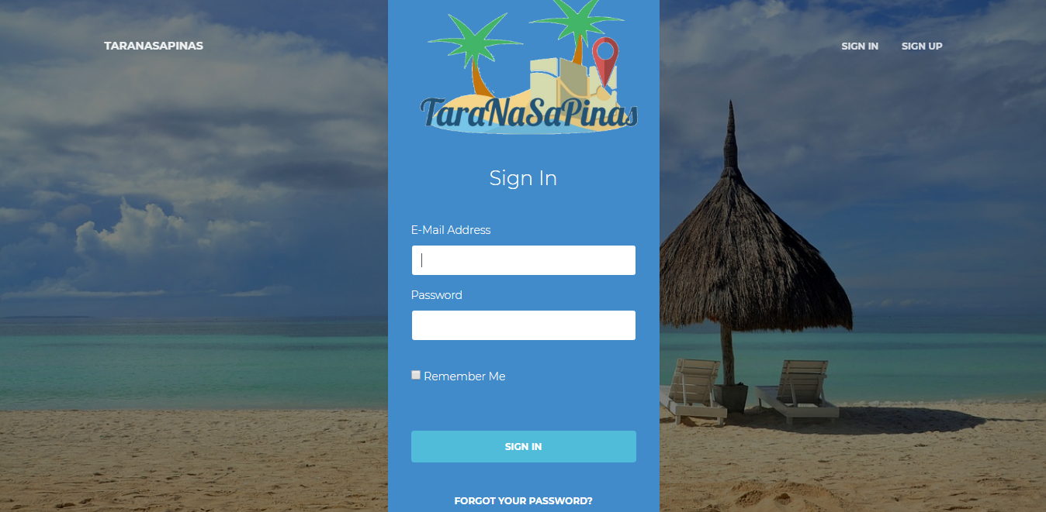

Figure 15. Web Application - Sign In Page

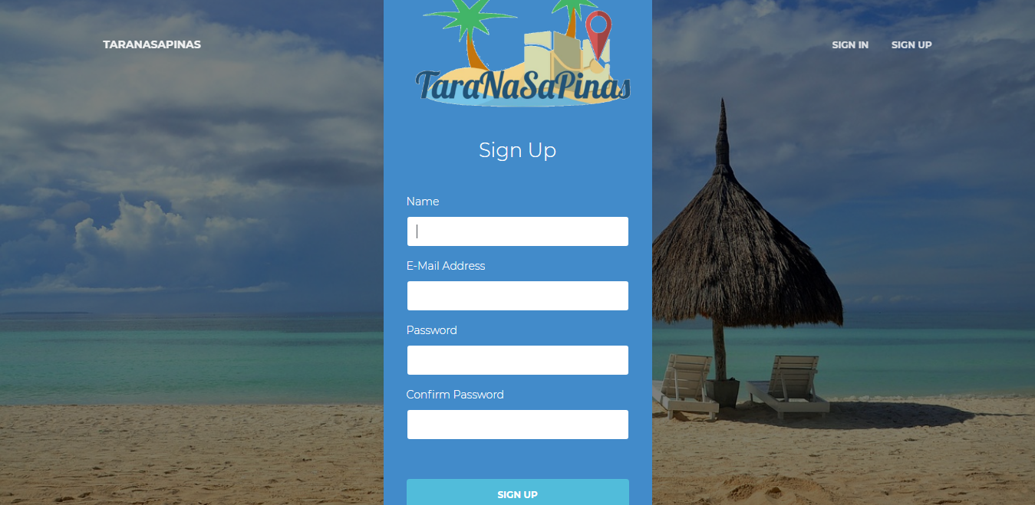

Figure 16. Web Application - Sign Up Page

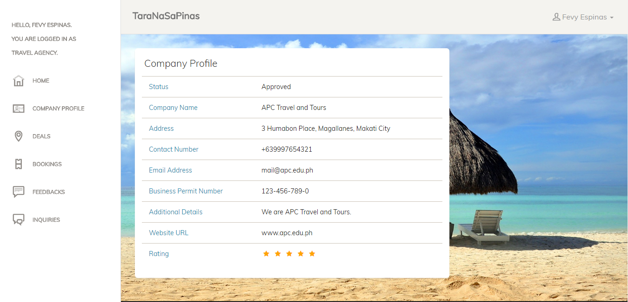

Figure 17. Web Application - Company Profile Page

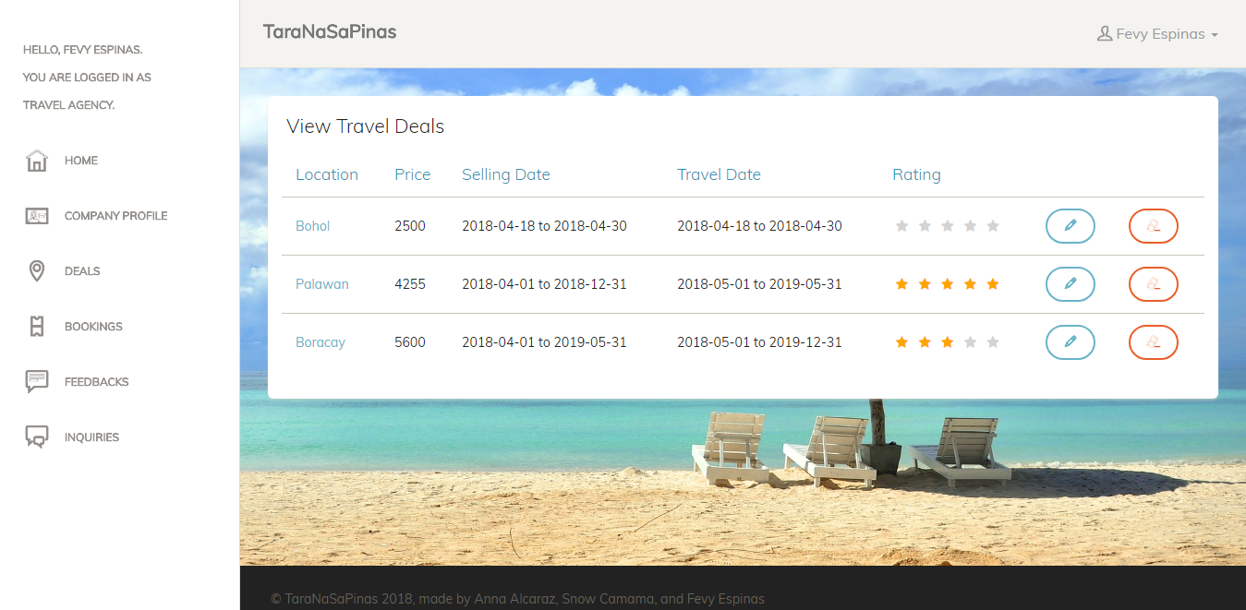

Figure 18. Web Application - Deals Page

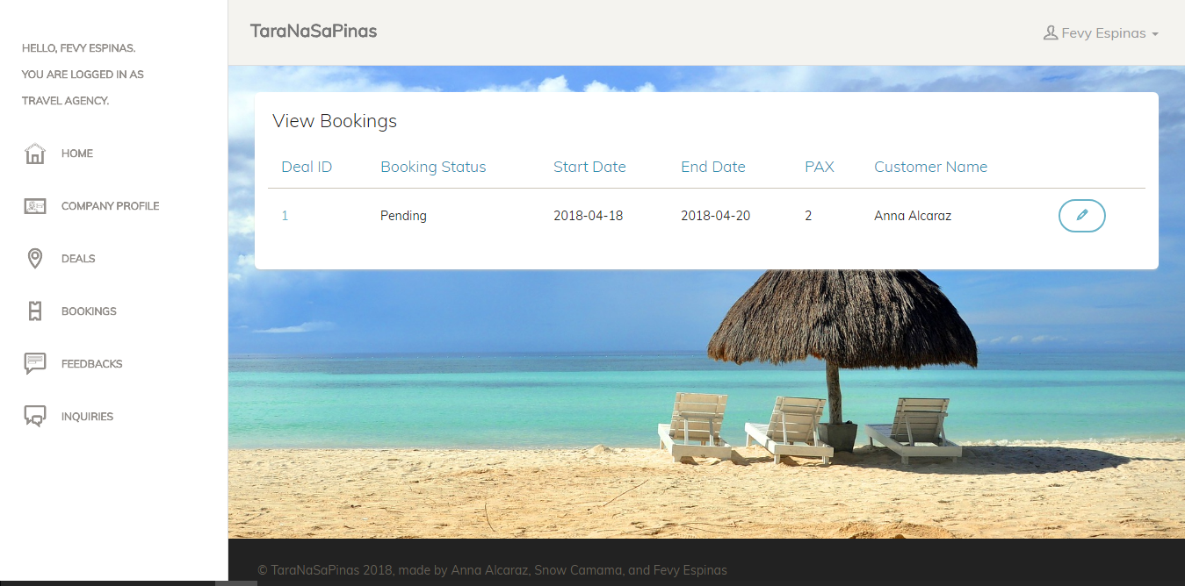

Figure 19. Web Application - Bookings Page

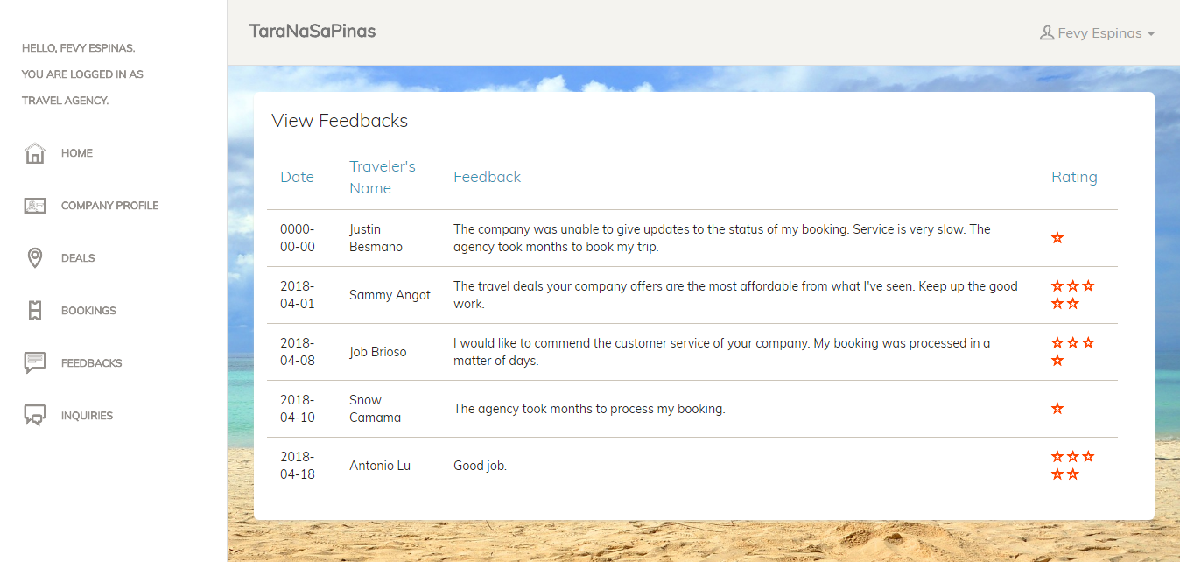

Figure 20. Web Application - Feedbacks Page

### Implementation Plan (Infrastructure/Deployment)

As for the initial document, the project is based from a client that already has the document that clarifies the scope of the entire project. Including the features, wireframes, diagrams, etc.

## Results and Discussions

Based from the market survey conducted by Ms. Marielet Guillermo, she stated that ‘Survey results show that biggest contributor in the final pain point is ‘Inadequate information on available schedule’ followed by ‘No record of booked packages’. These imply that in the current situation, details about schedule or bookings may be recorded on the part of the agency however, they are not visible to travelers. It could be better if travelers would also have an easy access or visibility on their bookings in order to plan their travel well and much easier than before, avoiding much effort and time wasted for just looking at a suitable travel date, and possible conflict with prior bookings’ (Guillermo, 2018).

The survey’s conducted shows the need of travelers for a credible travel agency, addition to the inadequate information that they experience when booking for travel deals online. There is no particular application that has the similar functionality, thus travelers mostly look and book their deals on social media such as Facebook or Instagram.

## Conclusions and Recommendations

In conclusion, the application would be a great avenue to enhance the experience of travelers when booking travel deals, assuring their safety through having certified legitimate travel agencies. Also, in this light, local travel agencies would be more known thus increasing their demand overtime.

There can be several features that can be added to the application as well as to the web counterpart. Such features are the payment method of the traveler. The application can have this feature to ease the hassle of a traveler in paying his/her booking.

In part of the team’s recommendation would the expansion of the application through various countries, not just the Philippines. Because there are a lot of tourists that visit the country anytime of the year, it would be great avenue and benefit to the Philippine economy as well as to the Department of Tourism.

## Appendices

### Curriculum Vitae

|  |  |  |
| --- | --- | --- |
| **Name:** | **REHAM SNOW A. CAMAMA** | . |
| **Complete Address:** | Blk 14 Lot 21 Ridgeview Estates, Nuvali |
| Calamba City |
| **Contact Number/s:** | Landline: (049) 308 8931 |
| Mobile No.: (0999) 415 7758 |
| **Email Address:** | [racamama@student.apc.edu.ph](mailto:racamama@student.apc.edu.ph)  [reham.snow29@gmail.com](mailto:reham.snow29@gmail.com) |
| **Website:** | https://www.linkedin.com/in/reham-snow-camama-b4439291/ |

|  |  |
| --- | --- |
| **Personal Statement** | Eager to learn and a goal-oriented person that seeks to create the best of what she can deliver and contribute to a team, and is also dedicated to build a career and to experience more on the field of technology and business. |
| Education | **Asia Pacific College**, Magallanes, Makati City  **Bachelor of Science in Computer Science with specialization in Software Systems**  January 2016-present  **De La Salle University – Science and Technology Complex**, Binan, Laguna  **Bachelor of Science in Business Administration major in Operations Management**  June 2012 - October 2015 |
| **Work-Related Courses** | * Software Development * Project Management * System Analysis and Design |
| **Academic Projects** | **MAG-Report (Magallanes Report)**   * Barangay Disaster Preparedness, Security and Information Dissemination Application (Mobile and Web Application) * June 2017 – April 2018 * Project Manager * Included in MERGE 2018 exhibit   **TaraNaSaPinas**   * Travel Deals Booking Application (Mobile and Web Application) * January – April 2018 * Project Manager   **EEClub Website**   * Joomla Website Development * September 2017 – January 2018 * Web Master |
| **Technical Skills** | * Mobile Development: Android Studio * Web Development: Joomla, Visual Studio * Languages: JAVA, PHP, Python, Ruby, HTML and CSS |
| **Awards & Recognitions** | * 1st Place, Project 72 (Web Development Contest),   Asia Pacific College, August 2017   * Dean’s Lister, SY 2015-2016 |
| **Seminars & Trainings Attended** | * The Fight Against Counterfeiting   Asia Pacific College, April 2018   * 8th Global Business Conference   De La Salle University, February 2014   * When Good Guys Finish First: Social Entrepreneurship   College of Business, De La Salle University – Science and Technology Complex, February 2014   * Bigger, Better, Stronger, Power: Corporate Social Responsibility   College of Business, De La Salle University – Science and Technology Complex, February 2014   * Jumpstart Your Future: A Career Talk   College of Business, De La Salle University – Science and Technology Complex, November 2013 |
| **Extra-Curricular Activities** | * DLSU Central Committee University Week, Productions Executive, 2015 * Gakuen Anime Soshiki, Internal Vice President, 2012 - 2014 |

|  |  |  |
| --- | --- | --- |
| **Name:** | **ANNA LYNN C. ALCARAZ** | **CORPORATE photo**  Must fit in this box.  Strictly corporate attire. |
| **Complete Address:** | 37 Circle Drive, Cubic Homes |
| Merville, Parañaque |
| **Contact Number/s:** | Landline: 8220429 |
| Mobile No.: (0999) 884-5654 |
| **Email Address:** | [acalcaraz@student.apc.edu.ph](mailto:smangot@student.apc.edu.ph)  [annalynn.alcaraz@gmail.com](mailto:angot.sammy@gmail.com) |
| **Website:** | https://www.linkedin.com/in/anna-lynn-alcaraz/ |

|  |  |
| --- | --- |
| **Personal Statement** |  |
| Education | **Asia Pacific College**, Magallanes, Makati City  **Bachelor of Science in Computer Science**  **specializing in Systems Software**  January 2015-present |
| **Work-Related Courses** | * Database Management * Web Development * Systems Analysis and Design * Software Development * Project Management |
| **Academic Projects** | **Bus Tap**   * Passenger Information System for the Bonifacio Global City (BGC) Bus (Web and Mobile Application) * June 2017 – April 2018 * Project Manager, System Analyst, and Web Developer * Included in the MERGE 2018 exhibit of Asia Pacific College at the SM Mall of Asia (April 19-20, 2018)   **TaraNaSaPinas**   * Travel Deals Booking Application (Web and Mobile Application) * January 2018 – April 2018 * Web Developer |
| **Academic Projects (continued)** | **Guru Job**   * Job Matching Platform for Educators (Web Application) * January 2018 – April 2018 * Software Quality Assurance Team Project Manager   **Magallanes Village Association Website**   * Official Website of the Magallanes Village Association * September 2017 – January 2018 * Project Manager and Systems Administrator |
| **Technical Skills** | Web Development:   * Joomla, * Laravel, and * Ruby on Rails   Languages:   * SQL * C++, JAVA, Visual Basic, * HTML, CSS, * PHP, Python, and Ruby |
| **Awards & Recognitions** | * **Dean’s Lister**, AY 2016-2017 |
| **Seminars & Trainings Attended** | * The Fight Against Counterfeiting   Asia Pacific College, April 2018   * Xamarin Application Development Workshop   Asia Pacific College, July 2016 |

|  |  |  |
| --- | --- | --- |
| **Name:** | **Ma. Fevy C. Espinas** |  |
| **Complete Address:** | L318 Bonifacio Heights Residences, Lawton Avenue, Fort Bonifacio |
| Taguig City |
| **Contact Number/s:** | Landline: N/A |
| Mobile No.: (0927) 388-2421 |
| **Email Address:** | [mcespinas@student.apc.edu.ph](mailto:mcespinas@student.apc.edu.ph)  [mafevyespinas@gmail.com](mailto:mafevyespinas@gmail.com) |
| **Website:** | Top of Form  [www.linkedin.com/in/ma-fevy-espinas-83a707161](http://www.linkedin.com/in/ma-fevy-espinas-83a707161)  Bottom of Form |

|  |  |
| --- | --- |
| **Personal Statement** | A student of Asia Pacific College, who is looking for a career that fits to my chosen profession and gain quality experience that would enhance my skills and nurture further my God-given talent. |
| Education | **Asia Pacific College**, Magallanes, Makati City  **Bachelor of Science in Computer Science with specialization in Systems Software (BSCS-SS)**  June 2015-present |
| **Work-Related Courses** | * Web Development * Software Quality Management * System Analysis and Design |
| **Academic Projects** | **Magallanes Report (MAG-Report)**   * Overall Barangay mobile and web application * June 2017 – April 2018 * Systems Analyst/System Developer * Included in APC, Merge 2.0 exhibit   **TaraNaSaPinas**   * Travel and Tour Deals mobile and web application * January – April 2018 * Web developer   **Magallanes Village Association Website**   * Community portal web application * September – January 2018 * Web developer |
| **Technical Skills** | * Competent in PHP, HTML and CSS * Skilled in Ruby, Python and Java programming languages * Proficient in MS Office: Word, Excel, PowerPoint |
| **Awards & Recognitions** | * Cheers & Chants, 1st Runner Up   Asia Pacific College, 2015   * Speech Choir, 1st Runner Up   Asia Pacific College, 2015 |
| **Seminars & Trainings Attended** | * The Fight Against Counterfeiting   Asia Pacific College, April 2018   * Sans Impunity: Forum   Asia Pacific College, December 2017   * Introduction to Ethical Hacking   Asia Pacific College, July 2016 |
| **Extra-Curricular Activities** | * Junior Philippine Computer Society, Member, SY 2015-2016 * Explorer’s Club, Member, SY 2015-2016 * Youth for Christ, Member, SY 2015-2016 |

# References

Expedia.com.ph. (2018, April 12). *Cheap Hotels and Resorts Booking | Travel with Expedia Philippines*. Retrieved from Expedia.com.ph: https://www.expedia.com.ph/

Guillermo, M. (2018). WanderPinas.

INQUIRER.net BrandRoom. (2017, October 18). *Online travel agencies seen as future of Philippine tourism*. Retrieved from Inquirer.net: http://technology.inquirer.net/68136/online-travel-agencies-seen-future-philippine-tourism

Manila Bulletin. (2017, August 8). *From screen to the scene with Traveloka >> Manila Bulletin Technology*. Retrieved from Manila Bulletin: https://technology.mb.com.ph/2017/08/07/from-screen-to-the-scene-with-traveloka/

Perez, J. B. (2017, June 8). *Philippine Statistics Authority*. Retrieved from Contribution of Tourism to the Economy is 8.6 Percent in 2016: https://psa.gov.ph/tourism-satellite-accounts-press-releases

Traveloka. (2018, April 12). *Traveloka Philippines - Easy Online Booking for Hotels and Flights*. Retrieved from Traveloka: https://www.traveloka.com/en-ph/